
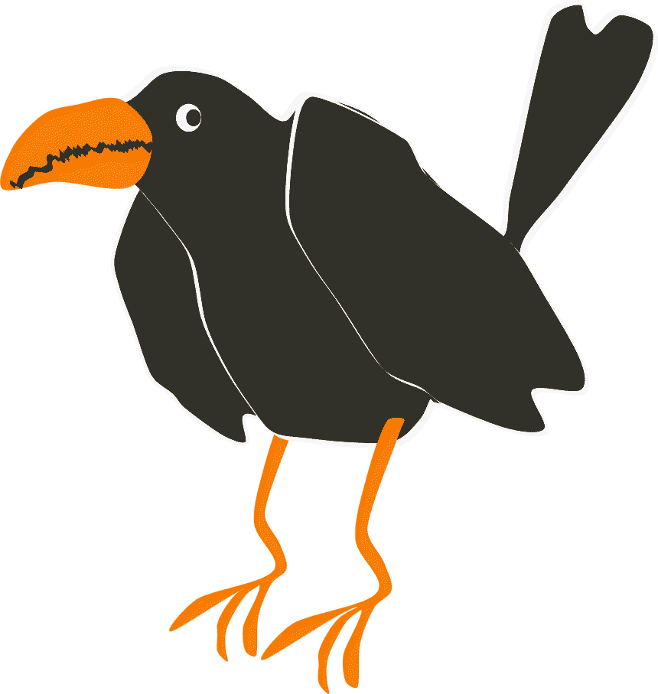
How to …
Add images and animate chosen objects in DrawPlus X4 stop-frame mode.

Step 1. Look for the “insert” tab on the menu bar and click it.
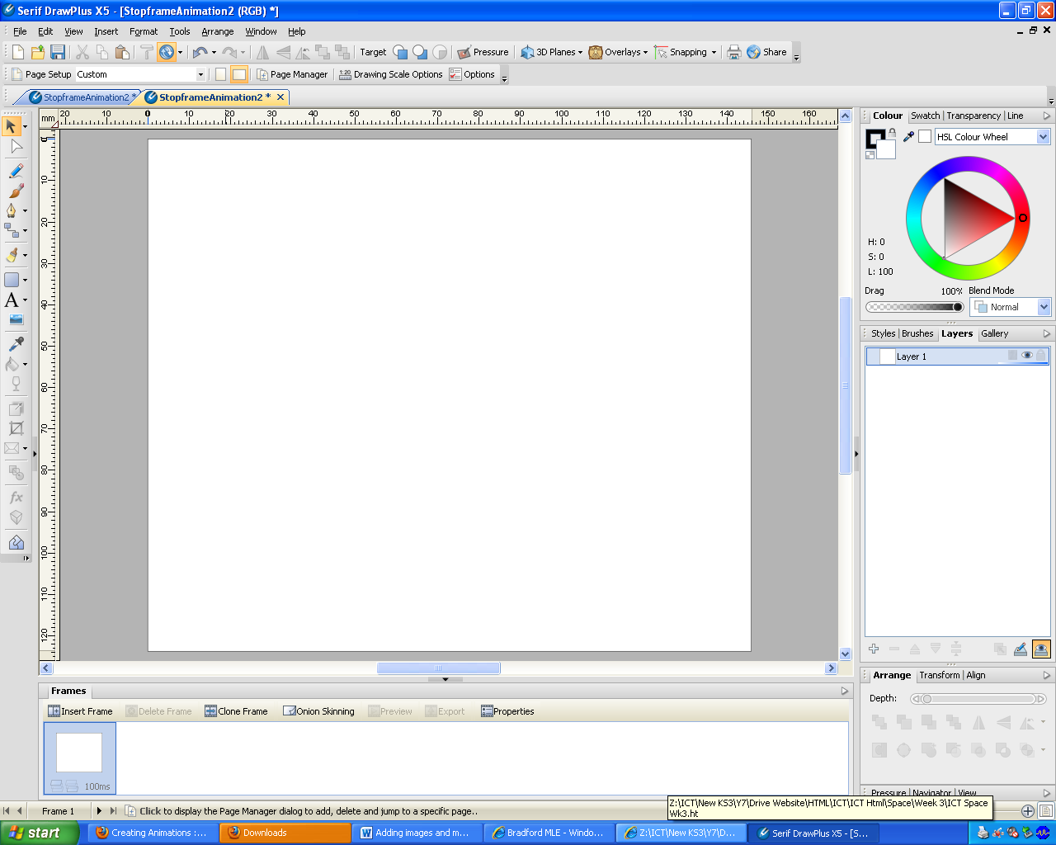

Step 2.
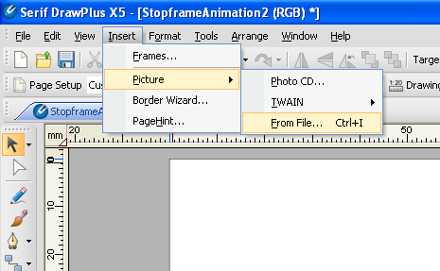
As you can see from the image on the right you then need to select “Picture” then “From File”

This will allow you to choose any pictures you have now gathered and saved into your week one space folder.

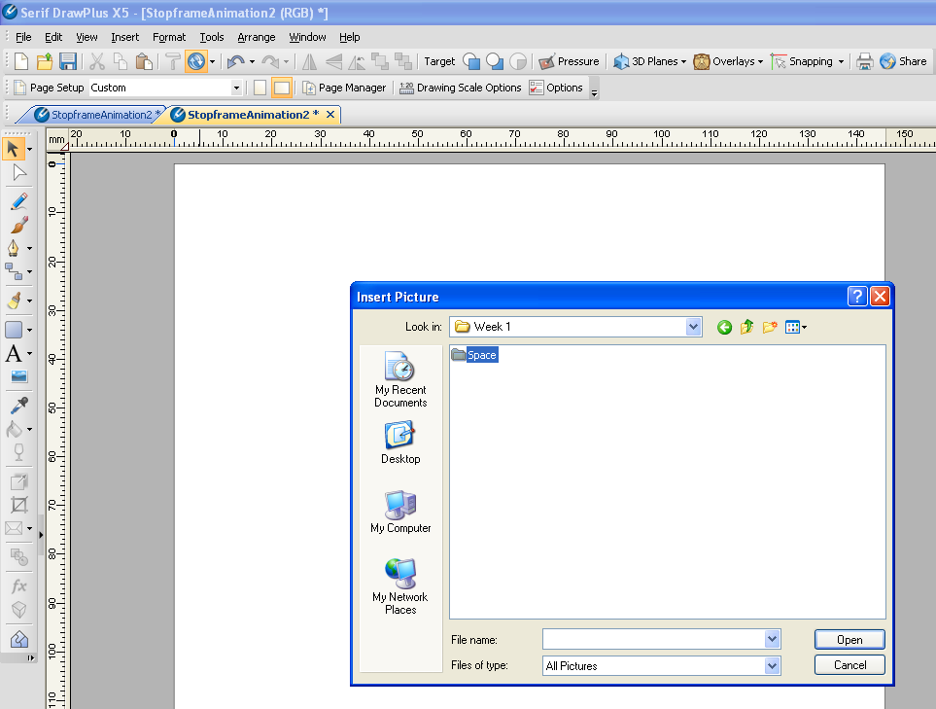
Select the picture you want and it will appear on the canvas.

I would recommend a background image first.

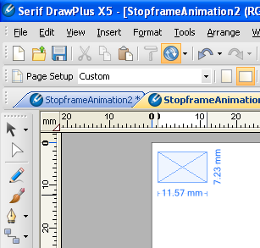 Step 3.
Click and hold then drag to fit your canvas background like I did in the next few screen shots.

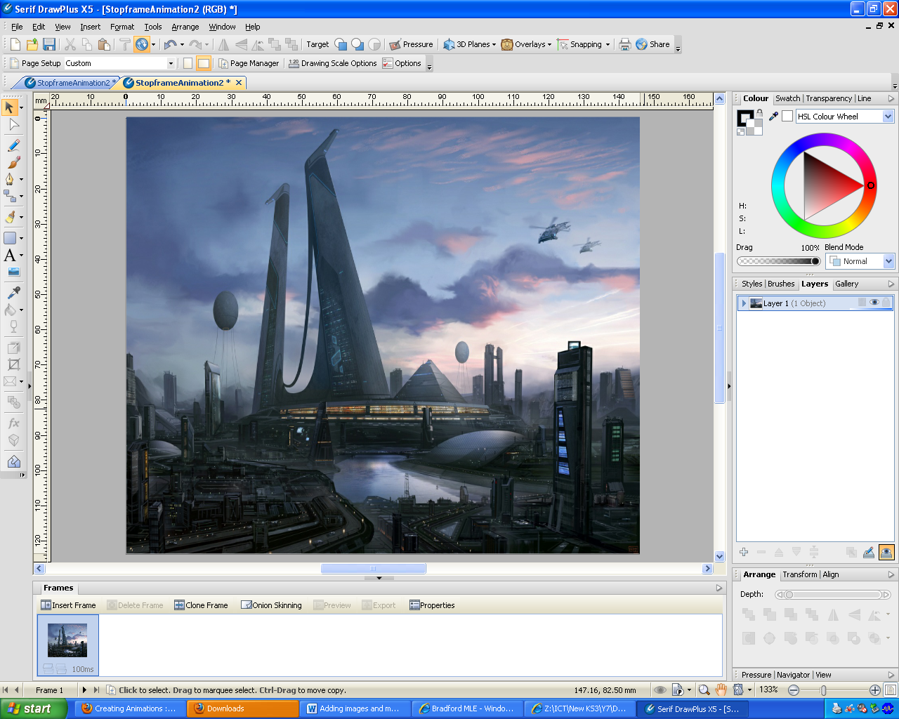
Make sure your background only covers the white are of the
canvas. You now repeat the above steps to add further objects to the canvas to be used in your animation.

